SIMATS ENGINEERING (SAVEETHA SCHOOL OF ENGINEERING)
Department of Computer Science and Engineering

ASSESSMENT TOOL 3– Output Prediction Questions

Course Code: | CSA0303 | Course Title: | Data Structures
CO Assessed: | CO1 | Assessment: | Assessment Tool 3 – Debugging and Optimization Questions
Weightage: | 10% of CIA | Total Marks: | 100
CO2 Statement: | Basics, Data, Data object, Data structure, Abstract Data Types (ADT), realization of ADT in ‘C’,  Primitive and non-primitive data structure, Linear and non-linear data structure Arrays & Recursion, Performance analysis and Measurement: Time and space analysis of algorithms, Average, best and worst-case analysis.
Student Name: | T DEEKSHITH | Reg. No.: | 192425145
Section / Batch: | B Tech Ai & DS | Date: | 26-07-2026

Code of Conduct
I K Sampath Reddy 192424285 certify that this submission is my original work and that I have adhered to the guidelines specified for this assessment. I understand that any violation of academic integrity rules will result in disciplinary action. Signature of the Student: Sampath reddy

Instructions
- This test contains 10 MCQ Based Questions. Total: 100 Marks.
- When a student answer using saveetha compiler, execute the code, Test the test cases , While evaluation the answer should contain following four requirements: Understanding of concepts, Connections between ideas, Logical structure, Clarity of representation.
- No negative marking. Unanswered questions carry zero marks.
- Electronic Gadgets are permitted in the class. Take it as test and submit in the saveetha lab compiler class.

Annexure A – Output Prediction Questions
1.Write a C program that takes an array as input and returns it reversed.
2.Write a C program for palindrome
3.Write a C program for Searching an Element in a Sorted Array
4.Write a C program for Count the Occurrences of an Element
5.Write a program for binary search
6.Write a C program for Merge Two Arrays
7.Write a C program for Find the Largest and Smallest Element in an Array
8.Write a C program for Find the Second Largest Element
9.Write a C program for Find the First and Last Occurrence of an Element 10.Write a C program for Find Missing Element in an Array

Rubrics for Calculation

Criteria | Weighta ge | Level 4 –  Exemplary |  | Level 3 –  Proficient | Level 2 –  Developing |  | Level 1 –  Beginning
Understanding of  Problem Context | 20 | Clearly understands the problem and accurately identifies all requirements |  | Good understanding with minor gaps | Basic understanding; some requirements unclear |  | Poor understanding or misinterpretation of the problem
Application of  Concepts | 30 | Accurately applies appropriate concepts to solve complex problems |  | Applies relevant concepts correctly with minor errors | Applies basic concepts with limited accuracy |  | Fails to apply appropriate concepts
Problem-Solving  Approach | 20 | Logical, wellstructured, and efficient approach |  | Mostly logical approach with minor gaps | Basic approach with some inconsistencies |  | Illogical or unclear approach
Accuracy of Solution | 20 | Completely correct solution with proper justification |  | Mostly correct with minor errors | Partially correct solution |  | Incorrect or incomplete solution
Clarity | 10 | Clear, wellorganized, and properly explained solution |  | Understandable with minor clarity issues | Limited clarity and explanation |  | Poorly presented and difficult to understand
Faculty In-charge |  |  | Course Coordinator |  |  | Program Director
Signature: _______________ |  |  | Signature: _______________ |  |  | Signature: _______________
Date: ___________________ |  |  | Date: ___________________ |  |  | Date: ___________________

CO2 Assessment Tool – 3 Data Structures

Name: K Sampath Reddy Reg No: 192424285 Course: Data Structures
Course Code: CSA0303

1st Question
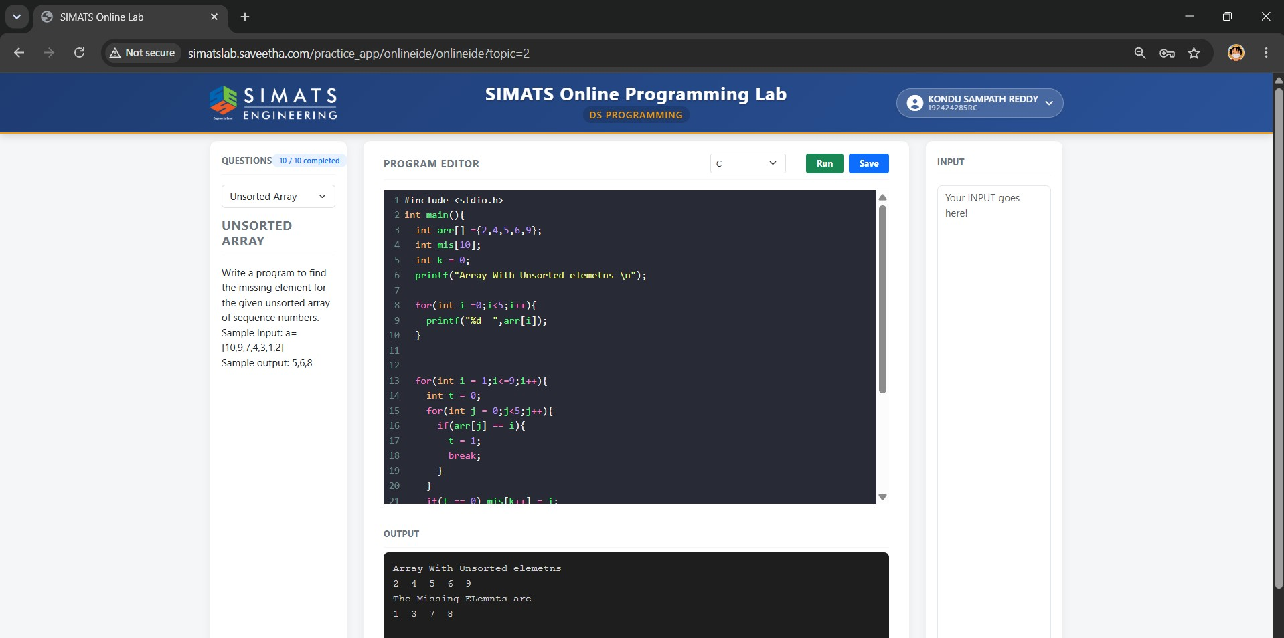
2nd Question

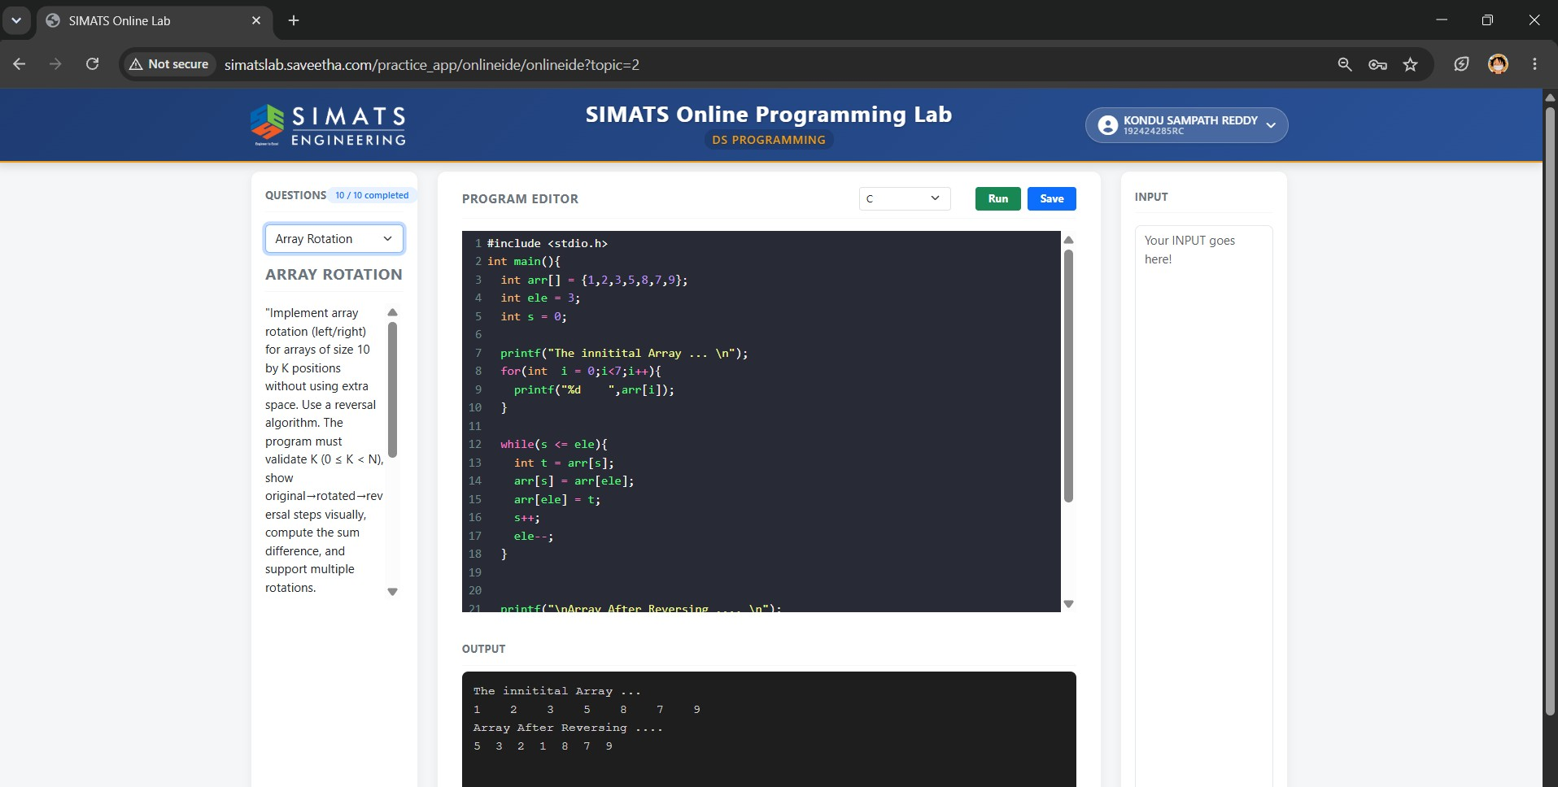

3rd Question
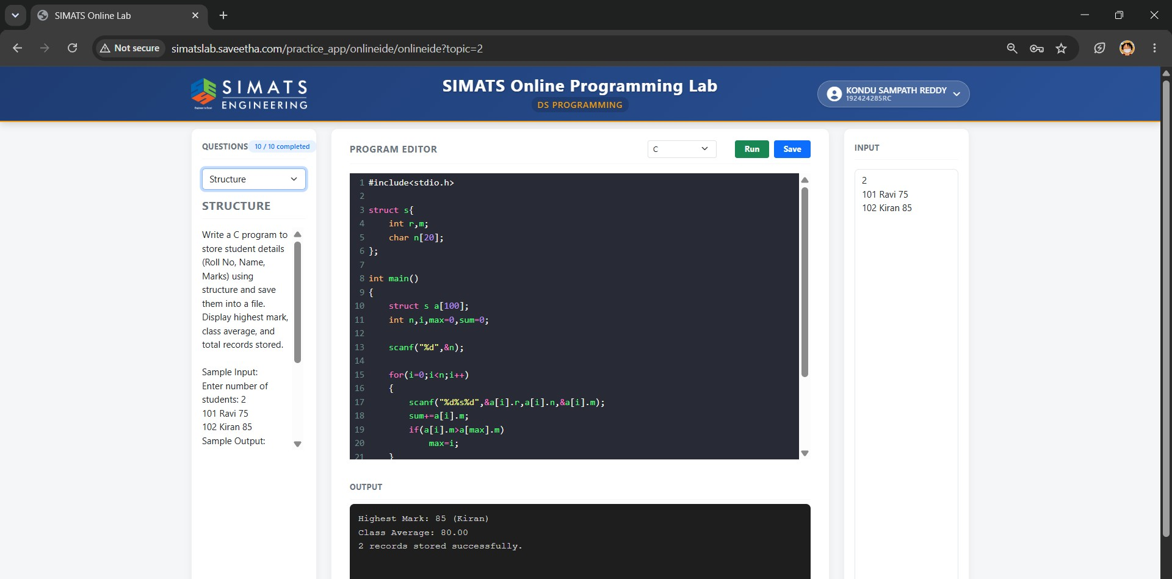

4th Question

